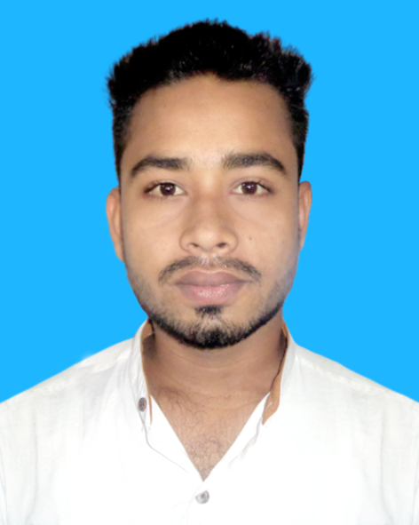
Curriculum Vitae

MD. SOJIB ALI

Cell Phone: +088 01752-079474
Current Address: Mohorkaya, Post: Bilmaria-6420
Thana: Lalpur, District: Natore.

Career Objective

Willing to build up a professional career in learning and original research activities, hence ensuring that all of my theoretical and practical knowledge will be properly utilized with increasing efficiency and skill where I will have the scope to utilize my potentiality, adaptability and skill to do something innovative through creativity, sincerity and devotion to duty.
Educational Qualification

Higher Secondary School Certificate (H.S.C)
College : Manjilpukur Agriculture, Technical & Commercial College, Natore.
Passing Year : 2018
Result : 4.79 (Out of 5.00)
Group : Business Management
Board : Bangladesh Technical Education Board, Dhaka.

Secondary School Certificate (S.S.C)
School : Bilmaria High School, Natore.
Passing Year : 2016
Result : 3.56 (Out of 5.00)
Group : Business Studies
Board : Rajshahi Education Board.

Computer & Software Skills
Skilled in MS Word, MS Excel, Power Point, Access Photoshop, Internet Browsing and E-mailing.

Experience
- 1 Year “Territory Sales Officer” Post of Job Experience Badon Toy Garden Company
- 1 Year “Seals Officer” Post of RDL.

Capabilities:
- Commanding Skill and capable of working under both at group and individual working environment.
- Target oriented hard- working ability. Like to take and face challenge.
Specialties:
- Self-confident, hard working.
- Communicative, Friendly and open minded.
- Patient, courageous, enthusiastic and punctual.
- Informative and immensely observant.

Language Competency

- Highly proficient at understanding, speaking, reading and writing English and Bangla.

Hobby’s

- Personal Interest : Travelling, Photography, Electronics Gadgets, Cars, Movies
Personal Information

Name : MD. SOJIB ALI
Father’s name : Md. Maidul Islam
Mother’s name : Mst. Sanoara Begum
Present Address : Vill: Mohorkaya, P/o: Bilmaria-6420
P/s: Lalpur, Dist: Natore.
Permanent Address : Vill: Mohorkaya, P/o: Bilmaria-6420
P/s: Lalpur, Dist: Natore.
Date of Birth : 29th December 2000
Nationality : Bangladeshi
Marital Status : Unmarried
Height : 5Feet 8Inche
Weight : 58kg
National ID : 5560145459

Declaration

I’m swearing that all the above information and included documents are correct and true of my knowledge.



Date : 12/08/2020 -------------------------------------
MD. SOJIB ALI

